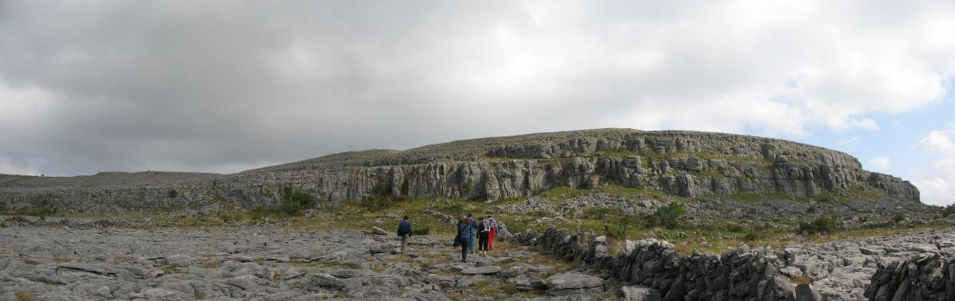
1
2
3
4,5
10
6,7,8,9
11,12
13 to 20
The Sphinx
Far Left
Ravens Zone
Watts Pillars
1. John Doe 2005, HVS 5a Watts  2. The Fugitive Sept 2006 S 3c? Warner  3. Long Route (not done) to be cleaned  4. Bill MacSway18/01/04 VS 5a Watts/Warner  5. DirtyThirty 18/01/04 Vdiff 3c Warner / Watts  6. E3 spotted by malcom  7. Comet Sept 06 S /HS 4a? Warner  8. Black Hole (or another name by malcom) Sept 06 Diff Warner  9. Hair Ball (Attempt Sept 2006) 5a?  10. Jack in the Box 18/01/04 (HVS?) Watts  11. Cacophony 2005 VS 5a Watts/Warner  12. Twin Cam 2005 S Warner /Watts  13. Ra Ra Re HS? 4a? Warner /Collins | 14. Tut Tut S? Warner / Collins  15. Cairo-Practor S? Warner / Collins  16. Seth-Upon HS 4a Warner / Collins  17. Seth-Up V.Diff Warner / Collins  18. Pharoah’s Prow August 2006 HS 4c? Warner  19. Cleo’s Cherry August 2006 Diff Collins  20. Lovely Luxor August 2006 HS 4b? Warner

RATHBORNEY VALLEY, Burren, Co. Clare
A crag at Croagh North /Burrenwee (near Newtown Castle) in the Rathborney Valley in the Burren directly across the valley from Ail na Cronan (Ailwee, Skull Rock). The crag is very accessible (less than 5 minute walk north from Rathborney valley road. The grades so far vary from V. Diff to HVS and are in general 8 to 15m high. There’s a very distinctive natural rock formation, the Sphinx, in the right hand side of the crag. The crag will be a good alternative to the more exposed crags in the area when the weather’s poor . The crag, which is generally south, south west facing extends for about 450m. The co-ords are 120900E, 205470N and is about 100m OD. This preliminary guide does not mean right of way. The routes are new and treat rock with care. Keep main road and gate entrances clear. Limited parking available at Rathborney graveyard. Up lane to main road turn right and then left up along private farm lane. (permission to access the lands yet to be sought from landowner).

Newtown Castle
Ballyvaughan
Aillwee Cave
To Lisdoonvarna
Corkscrew Hill
Skull Rock
Rathborney Church
Croagh Crag
Black Head
To Corofin

Far Left
- John Doe* HVS 5a (12m) Watts, Autumn 2005
To the far left of the crag at the bottom of the grass ramp, climb the obvious steep crack at the intersection of the horizontal and vertical crack, past a small overhang on the right and to the top.

- The Fugitive V. Diff (12m) Sept 2006
A few meters to the right of John Doe is an obvious shallow corner. Climb this taking care of some loose / hollow sounding slabs. Take care. Red flowering bush during September.

- (High Route)
Behind the trees is a 18-20m high cliff. One definite route in corner to right of holly tree at half height. Above are loose large flakes. Care advised. (not climbed yet)

Raven’s Zone
- Bill MacSway* HS 4b/ 4c (13m) Watts , Warner (19/1/04)
Start on small block under vertical wall with disjointed slab to right with hand hold. Up to ledge 4b/ 4c. Up to ledge (abandoned nest) under fantastic corner (3 to 4m high). The corner 5a and good gear to top.

- Dirty Thirty V.diff (13m) Warner, Watts (19/1/04)
Start to the right of Bill MacSway up to grass leadge to steep short wall, up to another ledge under steep wall. Up wall to top.

- Malcom’s E3
To the left of Comet is a smooth steep cliff that leads to good crack and to top. (not climbed yet)

- Comet* S 4a (10m) Warner, Collins Sept 2006
10m to the right of Bill MacSway is a good corner. Easy at first and then a good steep corner crack with good hand and foot jamming, to the top. Hollow sounding rock towards the top.

- Black hole Diff 10m Malcom
Immediately of the right of Comet is a deep chimney / crack. Body jam to top.

- Hair Ball, Sept 2006
To the right of Black hole is a definite arête. Hard opening overhanging moves (5a) using crack on right and thin foot flake on left leads to less steep terrain to the top of Black hole. (To be completed)

Watts Pillars
- Jack in the Box, HVS 5a (12m) (watts?) 19/1/04
When approaching from the farm lane, this obvious route is directly in line. Start on vertical wall at very thin shallow crack. Move to right and up sloping ledge below overhanging chimney. Climb chimney (3-4m) and exit to the right. There are several routes immediately to the right and left of this route but loose rocks above need to be removed. Care advised. The pillars in this area have the appearance of the statues on Easter Island.

- Cacophony* VS 5a (12m) Watts, Warner October 2005
15m to the right of Jack in the Box is a definite buttress / pillar (ivy covered on the right) . Start on the bottom left of the pillar at steep face / corner. Up Corner with excellent moves and out onto right onto steep face. Move left up onto top of sloping overhang and onto face to the left side of the pillar and use horizontal cracks to finish.

- Twin Cam S 4a (9m) Warner, Watts October 2005
15m to the right of Cacophony slightly up hill is a pair of cracks separated by wide flake. Up this to top using both cracks.

The Sphinx.

To the right of the crag is a fantastic balancing narrow detached block (7m high) on a narrow pedestal, standing proud of the main cliff. This featured known as the Sphinx is the left boundary on the right most section of the crag.

- Ra Ra Re *HS 4b? (9m) Warner Collins 15/10/06
An excellent little route at the left end side of the Sphinx Area. Obvious crack / groove to the left of the small bush / tree. Start on small holds on the left and work up into crack and up. Clean.

- Tut Tut *S 4a? (9m) Warner Collins 15/10/06
A good route. Obvious crack / groove immediately behind the small bush / tree. Up crack / groove on good holds and small flakes.

- Cairo-Practor *S 4a? (9m) Warner Collins 15/10/06
A good route. Obvious crack / groove immediately to the right of the small bush / tree. Up crack to small overhang in groove. Above easier on clean slope in deep grove cut

- Seth Upon HS 4b? (9m) Warner Collins 15/10/06
Tougher than it first looks. Obvious crack / groove immediately to the right of the Cairo-Practor. Up groove to small ledge on left and thin block (yellow) on right. Crux to get above grove onto face and directly to the top. Trat rock with care nearer top. (Small wedge of petrified tree route near top).

- Seth Up V.Diff? (9m) Warner Collins 15/10/06
Immediately to the right of Seth Upon in broken looking bay of yellowish rock. (Rock seemed ok on first ascents). Up and move left towards top of Seth Upon

- Pharaoh’s Prow HS 4c? (10m) Warner (to be lead) August 2006
The left prow of a deep steep narrow gully. Overhanging start onto steep pillar and little ledge with very small holly bush. More easily onto the top.

- Cleo’s Diff (10m) Collins (to be lead) August 2006
The deep steep narrow gully behind a tall thin thorn bush. Up carefully taking great care of the rock.

- Lovely Luxor HS 4b (10m) Warner August 2006
To the right of Cleo’s is a steep 10m high buttress. Climb into left trending rising crack after slightly overhanging start. Up steeply to crack to the left of corner and on to the top.

.
The Sphinx, Croagh North, Rathborney
Front View
Side View
East Face
7m
1.5m

